

NAME: BISMA FATIMA
CLASS: CS A
ROLL NO: F24605036
COURSE: ARTIFICIAL INTELLIGENCE
COURSE CODE: CS-281
LECTURER: SIR IJLAL HAIDER

MES

QUESTION NO 1:
import numpy as np
import matplotlib.pyplot as plt

t = np.random.randint(5, 45, 12)
print(t)

print("Minimum =", t.min())
print("Maximum =", t.max())
print("Mean =", t.mean())
print("Months > Mean:", t > t.mean())

x = np.array([1, 2, 3, 4, 5, 6, 7, 8, 9, 10, 11, 12])

plt.xlabel('Month')
plt.ylabel('Temperature (°C)')

max = np.argmax(t)
min = np.argmin(t)

plt.plot(x, t, marker='o', color='black', label='Temperature')
plt.plot(x[max], t[max], marker='o', color='red', label='Highest')
plt.plot(x[min], t[min], marker='o', color='blue', label='Lowest')

plt.legend()
plt.show()

OUTPUT:
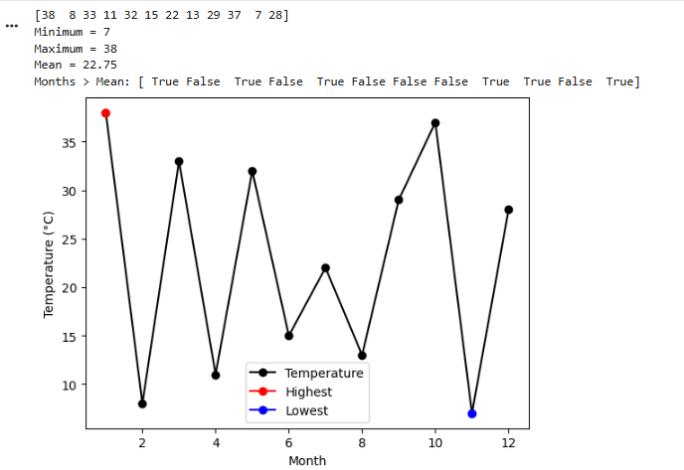
QUESTION NO 2:
import heapq

# Define the graph as an adjacency list with edge weights
graph = {
'A': {'D': 6 , 'B': 6},
'B': {'C': 10, 'E': 10},
'C': {'F': 7, 'D': 6},
'D': {'H': 4},
'E': {'F': 6},
'F': {'H': 6},
'H': {'G': 3},
'G': {}
}

# Heuristic values for each node (example values)
heuristics = {
'A': 12,
'B': 19,
'C': 13,
'D': 6,
'E': 6,
'F': 4,
'H': 3,
'G': 0
}

def greedy_best_first_search(start, goal):
visited = set()
priority_queue = []
heapq.heappush(priority_queue, (heuristics[start], start))
came_from = {start: None}

while priority_queue:
_, current = heapq.heappop(priority_queue)

if current == goal:
break

visited.add(current)

for neighbor in graph[current]:
if neighbor not in visited:
heapq.heappush(priority_queue, (heuristics[neighbor], neighbor))
if neighbor not in came_from:
came_from[neighbor] = current

# Reconstruct path
path = []
node = goal
while node:
path.append(node)
node = came_from.get(node)
path.reverse()

return path

# Run the search
path = greedy_best_first_search('A', 'G')
print("Greedy Best-First Search Path:", " → ".join(path))

OUTPUT
QUESTION NO 3:
def dfs(graph, start):
visited = set()
traversal_order = []

def dfs_helper(node):
visited.add(node)
print(node, end=" ") # Print node as it's visited
traversal_order.append(node)
for neighbor in graph[node]:
if neighbor not in visited:
dfs_helper(neighbor)

dfs_helper(start)
return traversal_order

# Example usage with the graph in the image
graph = {
'A': ['B', 'C'],
'B': ['D', 'E'],
'C': ['F'],
'D': [],
'E': ['G'],
'F': [],
'G': []

}

start_node = 'A'
print("DFS Traversal:")
dfs(graph, start_node)

OUTPUT:
